|  |  |  |  |  |
| --- | --- | --- | --- | --- |
|  | | | | |
|  | SHOPNEST STORE  POWER BI CAPSTONE PROJECT REPORT 16/03/2025BHARATH N bharathachar0911@gmail.com |  |  |  |

|  |  |  |
| --- | --- | --- |
| Ecommerce Background Images - Free Download on Freepik  SHOPNEST STORE  Leading Department Store in E-Commerce Marketplaces in Portugal | | |
|  | ABSTRACT The Power BI dashboard for ShopNest store is designed to provide a comprehensive analysis of key business metrics, enabling data-driven decision-making. The dashboard consolidates multiple visualizations to offer insights into sales performance, order trends, customer behavior, and revenue analysis.  This dashboard provides a holistic view of ShopNest’s business performance, helping stakeholders make informed strategic decisions. |  |

|  |  |  |  |  |  |  |  |
| --- | --- | --- | --- | --- | --- | --- | --- |
|  | TOP CATEGORIES BY TOTAL PRICE  * The **Health & Beauty** category is the top-selling, generating **1.26M** in sales, followed by **Watches & Gifts** at **1.21M**. * **Bed, Bath & Table, Sports & Leisure, and Computers & Accessories** also show strong performance, each exceeding **900K** in sales. * **Furniture & Decor, Cool Stuff, Housewares, Auto, and Garden Tools** complete the top 10 list, with sales ranging between **0.49M - 0.73M**.   This analysis highlights customer preferences, with personal care, home essentials, and electronics driving the highest sales. Businesses can use this insight to focus on high-demand categories while improving marketing strategies for lower-performing ones. | | | | | |  |
|  | DELAYED ORDERS ANALYSIS  * **Bed, Bath & Table** has the highest number of delayed orders (**689**), followed by **Health & Beauty** (**650**). * **Sports & Leisure, Furniture & Decor, and Computers & Accessories** also face significant delays, ranging from **400 to 500** orders. * Categories like **Watches & Gifts, Housewares, and Telephony** see moderate delays (**300-400 orders**). * Lower delays are observed in **Toys, Baby Products, Garden Tools, and Cool Stuff**, all below **250 orders**. * The **Pet Shop** category experiences the fewest delays, with only **86 orders affected**.   This analysis highlights areas where logistics and supply chain improvements could reduce delivery delays, especially in high-demand categories. | | | | | |  |
|  | MONTHLY COMPARISON OF DELAYED AND ON-TIME ORDERS  * **Peak On-Time Orders**: August had the highest on-time order count (**10.3K**), followed by May and July (**10K each**). * **Peak Delayed Orders**: March had the highest delayed orders (**1.4K**), followed by February (**1K**) and November (**0.9K**). * **Months with Lowest Delays**: June, September, and October had minimal delays (**0.2K each**). * **End of Year Trend**: On-time orders dropped in November (**6.6K**) and December (**5.3K**), while delayed orders slightly increased in November (**0.9K**).   This suggests potential operational challenges in the first quarter and during the holiday season, possibly due to demand surges or logistical constraints. | | | | | |  |
|  | PAYMENT METHOD ANALYSIS  * **Most Used Payment Method:** Credit card transactions dominated, accounting for **73.92% (76.80K transactions)** of all payments. * **Popular Alternative:** Boleto was the second most preferred method, making up **19.04% (19.78K transactions)** of total transactions. * **Growing Payment Type:** Voucher payments saw **5.56% (5.78K transactions)** of total payments, with a notable **47% increase**, indicating a rising trend. * **Least Used Payment Method:** Debit card transactions were minimal, totaling **1.53K**, making it the least preferred payment option.   The dominance of credit cards suggests a strong preference for flexible payments, while the growth in voucher payments may indicate increasing adoption due to promotions or corporate benefits. | | | | | |  |
|  | PRODUCT RATING ANALYSIS  * **Highest Rated Product Category:** CDs, DVDs, and Musicals had the highest average rating **(4.67),** followed by Fashion - Children's Clothes (4.50) and Books - General Interest **(4.46).** * **Lowest Rated Product Category:** Security & Services received the lowest rating **(2.50),** followed by Office Furniture **(3.61)** and Fashion - Male Clothing **(3.68).** * **Delayed Orders with High Ratings:** Despite delivery delays, products like CDs, Books, and Children’s Clothes maintained strong ratings, indicating high customer satisfaction with product quality. * **Categories with Low Ratings & Delays:** Office Furniture and Security & Services had both lower ratings and delayed orders, suggesting potential concerns with quality or service expectations.   Entertainment and book-related products maintain high satisfaction, while service-based and office-related items struggle with ratings, possibly due to performance issues or unmet customer expectations. | | | | | |  |
|  |  |  |  |  |  |
|  |  |  |  |  |  |
|  | | STATE-WISE SALES ANALYSIS  * **Highest Sales Region:** South America, particularly Brazil, has the highest sales volume, indicated by the largest bubble size. * **Moderate Sales in North America:** The U.S. has multiple sales points with moderate transaction volumes. * **Limited Sales in Asia & Europe:** Only a few sales data points are visible in these regions, suggesting lower market penetration. * **Expansion Opportunity:** The presence of sales in India and Australia indicates emerging markets that can be explored for growth.   This suggests that South America is the primary market, while North America remains a secondary hub, with opportunities to expand in Asia and Europe. | | | | | |  |

|  |  |  |
| --- | --- | --- |
|  | SEASONAL SALES PATTERNS  * **Highest Sales in Q2:** Sales peaked at **30.7K** in Q2, indicating strong seasonal demand. * **Gradual Decline Post-Q2:** Sales dropped from **26.6K in Q3** to **19.0K in Q4**, showing a year-end slowdown. * **Consistent Q1 Performance:** Q1 maintained stable sales (**27.6K**), suggesting a steady start each year. * **Sharp Q4 Decline:** The lowest sales (**19.0K**) in Q4 may be due to reduced consumer spending or post-holiday effects.   The data suggests a strong mid-year sales peak (Q2), followed by a decline towards year-end. Businesses should focus on Q3-Q4 strategies, such as festive promotions and targeted discounts, to sustain sales momentum. |  |
|  | REVENUE ANALYSIS  1. **Yearly Revenue Growth:** The total revenue increased significantly from **0.1M in 2016** to **7.2M in 2017** and further to **8.7M in 2018**, indicating rapid business expansion. 2. **Order Volume Increase:** The count of orders rose from **45K in 2017** to **54K in 2018**, showing increased customer engagement and purchase frequency. 3. **Overall Performance:** The total revenue accumulated across all years is **16.01M**, with **103.89K total orders** and an **Average Order Value (AOV) of 154.10**, suggesting a stable revenue model. 4. **Market Expansion:** The business has covered **4,119 cities** and served **99.44K customers**, reflecting strong geographical penetration and customer base expansion.   The revenue analysis highlights a consistent upward trend in revenue, order volume, and customer acquisition, showcasing business growth and operational efficiency. The steady increase in orders and revenue per order suggests a scalable and sustainable business model with strong market reach. |  |

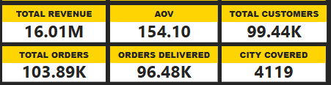

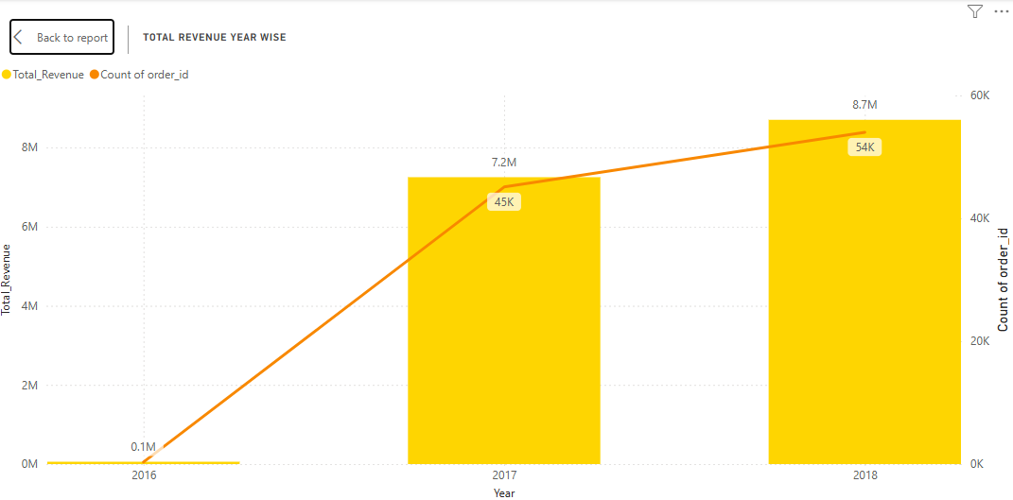

|  |  |  |
| --- | --- | --- |
|  | CONCLUSION The analysis of sales, delays, customer preferences, and revenue trends provides valuable insights into business performance and market opportunities. **Health & Beauty, Watches & Gifts, and home-related categories** dominate sales, highlighting strong consumer demand in these segments. Meanwhile, logistics challenges in high-selling categories such as **Bed, Bath & Table** and **Health & Beauty** suggest a need for supply chain improvements. A comparison of **monthly delayed and on-time orders** reveals seasonal fluctuations, with **peak delays in March** and **strong on-time performance in August**, pointing to potential operational inefficiencies during high-demand periods. The **state-wise sales analysis** confirms that South America remains the strongest market, while emerging opportunities exist in Asia and Europe.  **Payment method trends** indicate that credit cards remain the most preferred mode, while **voucher payments show promising growth**, suggesting a shift towards alternative payment options. Additionally, **product rating insights** reveal high customer satisfaction in entertainment and book-related products, while **service and office-related categories require quality improvements**. From a financial standpoint, the **consistent revenue growth** from **0.1M in 2016 to 8.7M in 2018** and a total revenue of **16.01M** reflect a **scalable and sustainable business model** with increasing customer engagement and strong geographical expansion. However, the **seasonal sales pattern** shows a **sharp Q4 decline**, indicating the need for strategic initiatives such as holiday promotions to sustain momentum.  By leveraging these insights, businesses can refine **inventory management, optimize marketing strategies, improve logistics, and expand into emerging markets** to drive long-term growth and profitability. |  |